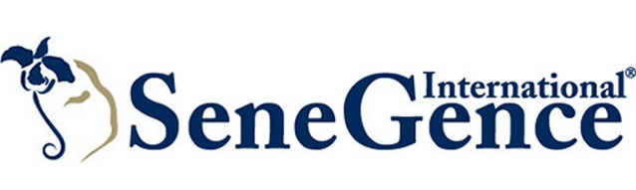

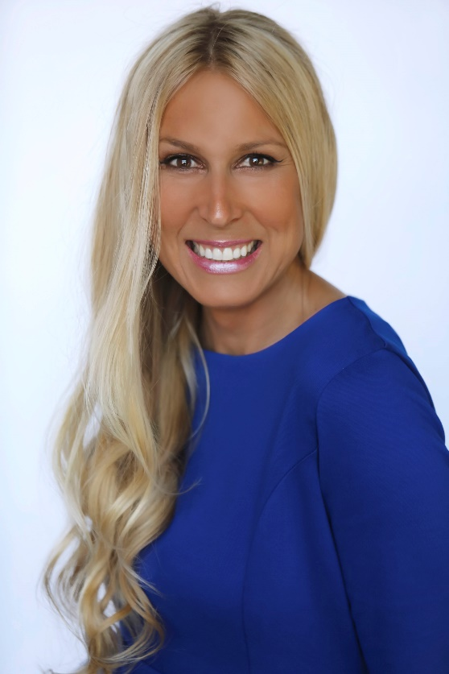
SeneGence International® Welcomes Melanie McGuire as Vice President of Global Events

Foothill Ranch, Calif. – (July 23, 2018) – Global beauty brand SeneGence International® has welcomed Melanie McGuire as vice president of global events. With nearly 20 years of event experience spanning countries across Europe, Middle East, Asia and North America, McGuire is responsible for overseeing the strategy, execution and success of the company’s 25+ annual events in more than 10 countries.

“McGuire’s extensive event expertise is a huge asset to our executive team, and we are grateful to have her on board,” said Joni Rogers-Kante, CEO, SeneGence International. “As SeneGence continues to grow our presence globally, a skilled individual with significant experience on an international scale is crucial. McGuire is exactly that.”

Most recently, McGuire was director of global event operations and global engagement at Society of Exploration Geophysicists in Tulsa, Okla., where she managed the global event operations teams of 20 people in the U.S., Dubai, United Arab Emirates, and Beijing, China. In this role, she also directed the

efforts of and collaboration for Global Business Development and Member Engagement. Prior to that, McGuire served as senior event operations manager at Pennwell Corporation and director of facility and event services at Oral Roberts University.

SeneGence is best known for its top-selling product, LipSense®, the original long-lasting lip color, which is unlike any conventional lipstick, stain or color. As the original long-lasting lip color, it is water proof, smudge proof, kiss proof and will not budge for up to 18 hours. Beyond its line of color cosmetics, SeneGence International also offers a revolutionary line of skin care products containing a proprietary formulation of ingredients called SenePlex Complex that produces real, visual, and clinically-proven results. It’s based on a kinetic enzyme that fights the signs of aging by more rapidly renewing skin cells and improving the appearance of one’s skin.

SeneGence does not test on animals or use animal by-products, and instead uses naturally occurring ingredients that have been approved by the FDA. All products are made in the United States for stringent quality control. To get in touch with a SeneGence Independent Distributor to try their revolutionary line of skin care and cosmetics, visit SeneGence.com.

Follow SeneGence on Twitter, Pinterest, Instagram, Facebook and YouTube.

About SeneGence International
SeneGence’s full line of long-lasting cosmetics and anti-aging skin care is sold through a network of Independent Distributors around the world. SeneGence proudly distributes products that are made in the U.S.A. and formulated without lead or animal testing. To find a Distributor near you or to get more information on SeneGence products and business opportunities, please visit www.SeneGence.com.

Media Contacts:
Katie Olivier
Sunwest Communications for SeneGence International
469.547.0016
kolivier@sunwestpr.com

