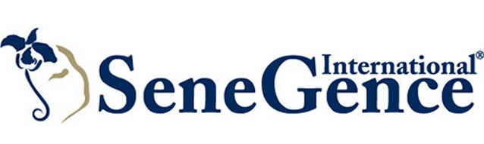
Add Some Giddy Up to Your Make Up with Limited-Edition LipSense Colors from SeneGence International®
Foothill Ranch, Calif. – (Sept. 1, 2018) – Global beauty brand SeneGence International® introduces three, limited-edition LipSense colors inspired by the rustic, timeless tones and textures of Western culture. Country girl meets glamour goddess with these dreamy LipSense products.

Two highly requested, red lip colors are back by popular demand! Glam Doll LipSense, a deep, earthy red-brown tone and Brick LipSense, a yellow-based warm, rich red are available in limited quantities. Giddy Up LipSense makes its debut and rounds out this color trio with its lovely taupe/mauve color. All three limited-edition LipSense have a matte finish for a gorgeous, on-trend look.

“Red is one of our most requested colors, and with fall coming up, these three LipSense colors are a perfectly gorgeous addition to your wardrobe and makeup routine for the new season,” said Joni Rogers-Kante, CEO, SeneGence International. “Our limited editions are always exceedingly popular and sell out quickly which is why we’re staggering the launch timing of the Cowgirl Trio LipSense and Cowgirl Trio ShadowSense…which is coming soon!”

SeneGence is known for LipSense®, the long-lasting lip color that provides up to 18 hours of perfectly pigmented color in more than 50 shades. As the original long-lasting lip color, it is water-proof, smudge-proof, kiss-proof. LipSense comes in a wide variety of shades and textures for any skin tone, including frosts, mattes and shimmers. Create your own color palette by combining colors from more than 50 shades.

Much more than a lip color company, SeneGence also has a full line of long-lasting, anti-aging cosmetics and skin care products formulated for a variety of skin types. SeneGence does not test on animals or use animal by-products, and instead uses naturally occurring.

To get in touch with a SeneGence Independent Distributor to try LipSense or their revolutionary line of skin care and cosmetics, visit SeneGence.com.

Follow SeneGence on Facebook, Twitter, Pinterest, Instagram and YouTube.
###
About SeneGence International
SeneGence’s full line of long-lasting cosmetics and anti-aging skin care is sold through a network of Independent Distributors around the world. SeneGence proudly distributes products that are made in the U.S.A. and formulated without lead or animal testing. To find a Distributor near you or to get more information on SeneGence products and business opportunities, please visit www.SeneGence.com.

Media Contacts:
Katie Olivier
Sunwest Communications for SeneGence International
469-547-0016
kolivier@sunwestpr.com

