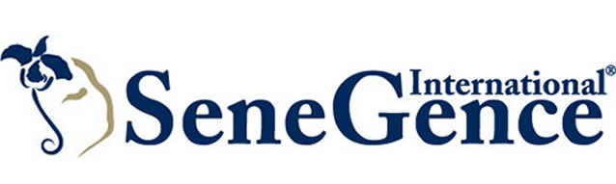
SeneGence International® Introduces Limited-Edition Hurricane Red LipSense®, Inspired by University of Tulsa
Foothill Ranch, Calif. – (Aug. 11, 2018) – Global beauty brand SeneGence International® introduces a limited-edition, limited-quantity LipSense®, Hurricane Red, which is inspired by University of Tulsa’s crimson red color and embodies the vivacious spirit of the school. Hurricane Red LipSense is a bold vibrant, warm red color with a matte finish that’s perfect for all skin tones. The gorgeous red shade is available for purchase in the U.S. only beginning Sat., Aug. 11 while quantities last.

“When we came up with the idea, we knew our first collegiate color had to be for University of Tulsa. It’s my hometown and we’re building a manufacturing facility plus offices in nearby Sapulpa…there wasn’t any doubt that our first color had to be for the Hurricanes,” said Joni Rogers-Kante, CEO, SeneGence International. “Red lips are a classic beauty trend and I have no doubt that Hurricane Red LipSense will be extremely popular.”

SeneGence is known for LipSense, the original long-lasting lip color that it is water-proof, smudge-proof and kiss-proof. LipSense and LipSense Gloss provide up to 18 hours of perfectly pigmented color with multi-dimensional texture to keep your pout looking perfect. SeneGence also has a full line of long-lasting, anti-aging cosmetics and skin care products formulated for a variety of skin types. SeneGence does not test on animals or use animal by-products, and instead uses naturally occurring ingredients.

To get in touch with a SeneGence Independent Distributor to try LipSense or their revolutionary line of skin care and cosmetics, visit SeneGence.com.

Follow SeneGence on Facebook, Twitter, Pinterest, Instagram and YouTube.
###
About SeneGence International
SeneGence’s full line of long-lasting cosmetics and anti-aging skin care is sold through a network of Independent Distributors around the world. SeneGence proudly distributes products that are made in the U.S.A. and formulated without lead or animal testing. To find a Distributor near you or to get more information on SeneGence products and business opportunities, please visit www.SeneGence.com.

Media Contacts:
Katie Olivier
Sunwest Communications for SeneGence International
214.363.1601 x241
kolivier@sunwestpr.com

